Outline of the Flow cytometry experiments: testing different carbon source transitions

1. cerevisiae cells are cultevited in Yeast nitrogen base (YNB) ,additionally added amino acid mix and vitamins, one group medium’s cabon source is 2% glucose, another group is 2% raffinose and inoculate overnight at 30°C.The first group is transitioned in 3 cases. They are Glu 2%-Glu 2%, Glu 2%-Gal 2%,Glu 2%-Raf 2%. The second group is Raf 2%-Raf 2%, Raf 2%-Gal 0.2%,Raf 2%-Gal 2%.

Preparation of Initial Cultures:

There are three strains used in the experiment: the wild-type strain YET181, YET911 which carries the Gal1p gene tagged with mScarlet, and Yet937 whose DOA1p gene is tagged with mScarlet. This means that for strains YET911 and YET937, when the cells induce the expression of GAL1 or DOA1, they will also start producing mScarlet. Consequently, these cells will exhibit fluorescence when measured using the measuring instrument.

Cells were cultivated in Yeast Nitrogen Base (YNB) supplemented with an amino acid mix and vitamins. Two distinct groups were prepared, with each group utilizing a specific carbon source:

a. Group 1: Glucose (2%)

b. Group 2: Raffinose (2%)

The cells were inoculated into their respective media and allowed to propagate overnight at a temperature of 30 °C.

Carbon Source Transitions:

Group 1 underwent three different carbon source transitions:

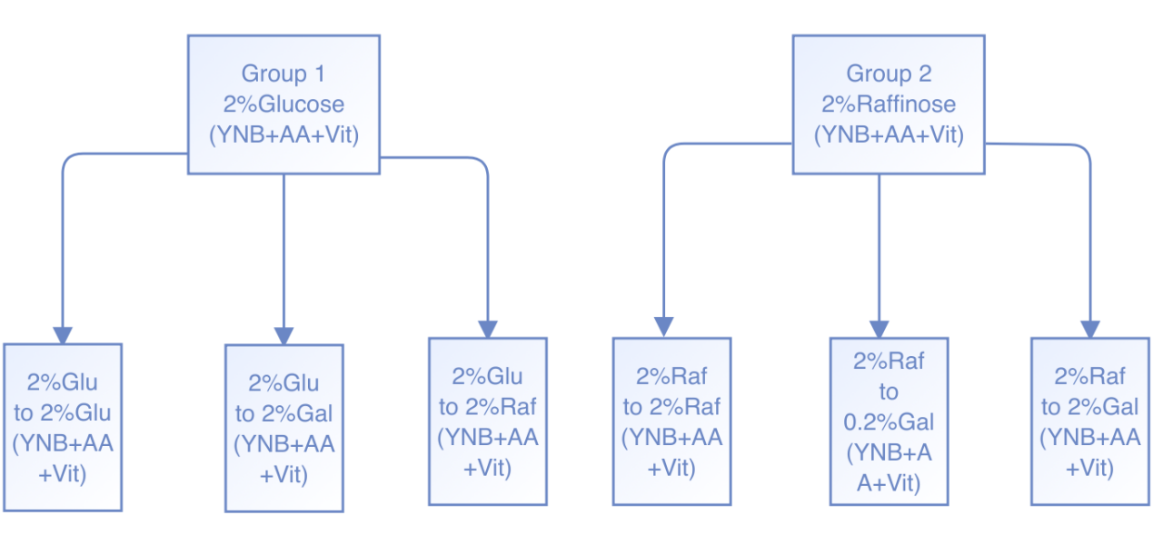

Glucose 2% to Glucose 2%

Glucose 2% to Galactose 2%

Glucose 2% to Raffinose 2%

Group 2 also underwent three different carbon source transitions:

Raffinose 2% to Raffinose 2%

Raffinose 2% to Galactose 0.2%

Raffinose 2% to Galactose 2%

Flow Cytometry Analysis

Before conducting flow cytometry analysis, the cells were diluted to OD600 of approximately 0.3 and then be sampled the culture at 20 time points with 15-minute intervals. The culture samples were incubated at 30 °C and shaken at 210 rpm. The collected samples, each with a volume of 1ml were intended for further analysis. Flow cytometry analysis as performed using the CytoFLEX S Flow Cytometer by BECKMAN COULTER to assess the cellular characteristics of the samples.

Describe what you see:

Are there differences between the two strains?

Under the same carbon transition from GlU to GAL, we can observe that both strains exhibit steady fluorescence expression over time. However, YET937 shows slightly higher florescence, which may be attributed to the higher expression of the DOA1 gene compared to the GAL1 gene. DOA1 plays a crucial role in S. cerevisiae DNA damage response by directing ubiquitin away from the proteasomal degradation pathway and towards pathways involved in modified DNA replication and chromatin modification(Lis & Romesberg,2006).

During the transition from RAF to GAL,YET911 initially demonstrates lower fluorescent expression than YET937 within the first 50 minutes. However, around the 40-minute mark, it begins exponentially increase and surpasses YET911 by 50 minutes. In contrast, YET937 maintains a steady expression throughout the observation period.

Are there differences between the conditions?

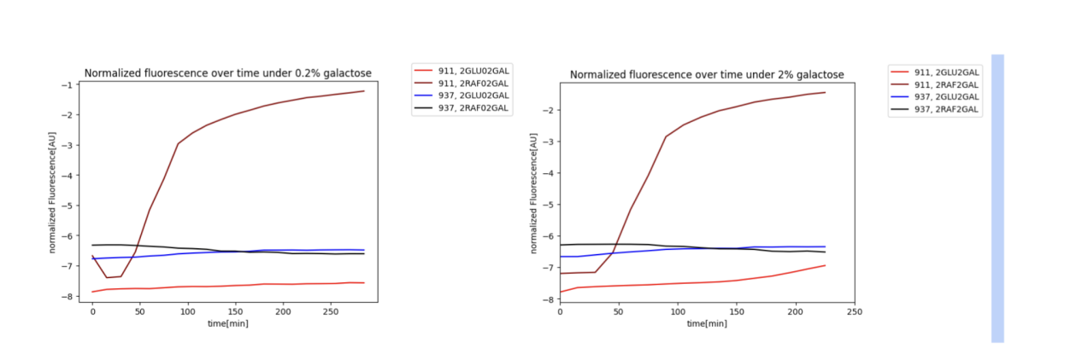

Fig.a Fig.b

We can observe that as the concentration of galactose transitions from 0.2% to 2%, the florescent expression follows a similar pattern as mentioned before. The subtle difference is that with higher galactose concentration, there is a more consistent expression of the GAL1 gene. In contrast, under 0.2% galactose, the florescent expression decreases initially, reaches a short steady state and then exponentially increases. However, under 2% galactose, the florescent expression is initially unchanged and then exhibits exponential growth. Moreover, higher galactose concentration allows for greater expression of the GAL1 gene. We observe a higher upward trend in fluorescent expression compared to the situation with 0.2% galactose.

The initial decrease observed in Figure a can be attributed to the GAL regulatory network.The key regulator in this network Gal4p, which is a transcriptional activator that binds to specific DNA sequences known as upstream activation sequences(UASG) as a homodimer. It subsequently activates gene transcription. Gal80p, on the other hand, acts as a negative regulator. In the presence of galactose, Gal3p, a signal transducer binds to Gal1p, leading to the activation of Gal4p,which allowing the fluorescent expression, which indicates GAL1 gene activity. However, during the transition from 2% raffinose to 0.2% galactose,

the avalaibility of galactose decreased, which lead to the dissociation of Gal3p from Gal1p, preventing the binding of Gal3p to bind Gal4p. As a result, there is a decrease in fluorescent expression(Pannala, Bhat, Bhartiya，& Venkatesh, 2010).

.

Pannala, V.R., Bhat, P.J., Bhartiya, S., & Venkatesh, K.V. (2010). Systems biology of GAL regulon in Saccharomyces cerevisiae. WIREs Systems Biology and Medicine, 2, 98-106. <https://doi.org/10.1002/wsbm.38>

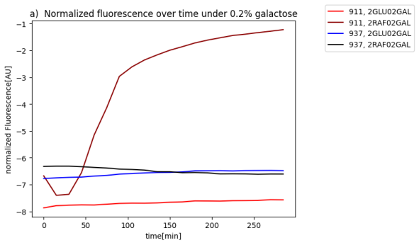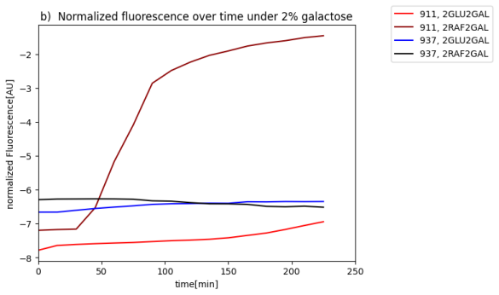

**Conclusions**

Mention the key take home messages of this work, in the light of the aim(-s), what have we

learned?

The key take home message

How do variable carbon conditions influence the adaptive responses of Saccha-

romyces cerevisiae, specifically through the lens of GAL1 expression within the

Leloir pathway?

Mig1 is responsible for glucose-dependent repression. It acts as a transcriptional repressor, which can attach to sequences located in the promoters of many glucose repressor genes such as Ssn6 and Tup1. In the absence of glucose, Mig1 is promptly transported into the nucleus but is quickly transported back to the cytoplasm when glucose is removed.The localization of Mig1 is phosphorylated by Snf1 kinase, which can notably repress the expression of Gal4. (Carlson, 1999).

Carlson, M. (1999). Glucose repression in yeast. Current opinion in microbiology, 2(2), 202-207.

There are two mechanism inhibit the GAL genes expression when glucose is deprived, the first is via glucose-dependent catabolite repression.Mig1 is responsible for it and it acts as a transcriptional repressor, which can attach to sequences located in the promoters of many glucose repressor genes such as Ssn6 and Tup1. In the absence of glucose, Mig1 is promptly transported into the nucleus but is quickly transported back to the cytoplasm when glucose is removed.The localization of Mig1 is phosphorylated by Snf1 kinase, which can notably repress the expression of Gal4. (Carlson, 1999). The second is GAL80, which serves as repressor bounds to Gal4 -transcription activator to inhibbit Gal gene expression.

In our research, we investigated the impact of different carbon conditions on S. cerevisiae, with a particular focus on the Leloir pathway of galactose utilization. Cells exhibit a preference for the most suitable carbon source to achieve optimal growth and fitness. Through analyzing the expression behavior of GAL1, we discovered significant insights into how variable carbon conditions affect S. cerevisiae, shedding light on the dynamics of galactose utilization in the Leloir pathway.

In our study, we built upon previous research that identified two mechanisms involved in inhibiting GAL gene expression under glucose-deprived conditions and to further explore our research question How do variable carbon conditions influence the adaptive responses of *S. cerevisiae*, specifically through the lens of GAL1 expression within the Leloir pathway. The first mechanism is known as glucose-dependent catabolite repression, which was previously described by Carlson(1999). In this mechanism, Mig1 is responsible for it and it acts as a transcriptional repressor, which can attach to sequences located in the promoters of many glucose repressor genes such as Ssn6 and Tup1. In the absence of glucose, Mig1 is promptly transported into the nucleus but is quickly transported back to the cytoplasm when glucose is removed.The localization of Mig1 is phosphorylated by Snf1 kinase, which can notably repress the expression of Gal4. The second mechanism, involves Gal80 acting as a repressor that binds to the Gal4 transcription activator, thereby inhibiting the expression of Gal genes.

By drawing upon these earlier findings, our study shed further light on the intricate interplay between carbon transitions and the Leloir pathway in *S. cerevisiae*.

*S.cerevisiae is a unicellular, best studied eukaryotes which get full sequenced by Goffeau et al. in 1996, and it’s a representative eukaryotes which conserve the most biological functions found in eukaryotes,*

*nearly all biological functions found in eukaryotes are also present and well conserved in S. cerevisiae, due to these natures, which simplifies mattters, it’s also easy to conduct gene manipulation.*

*S.cerevisiae is a well-studied unicellular eukaryote, its complete genome sequence was elucidated by Goffeau et al. 1996.Nearly all biological functions observed in eukaryotes can be identified and well-preserved in S. cerevisiae. This remarkable conservation greatly simplifies experimental investigations and enables convenient gene manipulation experiments in this organism.*

mrna FISH

what is glucose-dependent catabolite repression by Mig1

ChatGPT

Glucose-dependent catabolite repression refers to a regulatory mechanism in cells that inhibits the expression of certain genes involved in the utilization of alternative carbon sources when glucose is present. Mig1 (Mads-box transcriptional repressor Mig1) is a protein involved in this repression mechanism in yeast, specifically in Saccharomyces cerevisiae.

When glucose is available in the environment, yeast cells preferentially utilize glucose as their energy source. To ensure efficient glucose utilization, cells repress the expression of genes involved in the metabolism of other carbon sources, such as galactose or maltose. Mig1 plays a key role in this process.

Mig1 acts as a transcriptional repressor by binding to specific DNA sequences in the promoter regions of target genes. In the absence of glucose or in low-glucose conditions, Mig1 is phosphorylated and remains in the cytoplasm. However, when glucose levels are high, glucose is transported into the cell and metabolized, resulting in decreased levels of cAMP (cyclic adenosine monophosphate). The decrease in cAMP levels leads to the activation of protein kinase A (PKA).

Activated PKA phosphorylates Mig1, causing it to translocate from the cytoplasm to the nucleus. In the nucleus, Mig1 binds to the promoter regions of target genes involved in the utilization of alternative carbon sources, thereby repressing their transcription. This repression prevents the unnecessary utilization of alternative carbon sources when glucose is abundant.

In summary, Mig1 is a transcriptional repressor that mediates glucose-dependent catabolite repression in yeast. It is phosphorylated and translocates to the nucleus in response to high glucose levels, where it binds to target gene promoters, inhibiting their transcription and repressing the utilization of alternative carbon sources.

why Cells grown in raffinose do not experience glucose-dependent catabolite repression by Mig1.

My version:

Mig1 is responsible for glucose-dependent repression. It acts as a transcriptional repressor, which can attach to sequences located in the promoters of many glucose repressor genes such as Ssn6 and Tup1. In the absence of glucose, Mig1 is promptly transported into the nucleus but is quickly transported back to the cytoplasm when glucose is removed.The localization of Mig1 is phosphorylated by Snf1 kinase, which can notably repress the expression of Gal4. Snf1 also involved the transcription of gluconeogenic genes by regulating the two activators,Sip4 and Cat8’s expression and function(Carlson, 1999).

Carlson, M. (1999). Glucose repression in yeast. Current opinion in microbiology, 2(2), 202-207.

<https://doi.org/10.1016/S1369-5274(99)80035-6>

ChatGPT

Cells grown in raffinose do not experience glucose-dependent catabolite repression by Mig1 because raffinose is not directly metabolized into glucose within the cell. Glucose-dependent catabolite repression is specifically triggered by the presence of glucose or its immediate metabolites.

Raffinose is a trisaccharide composed of galactose, glucose, and fructose units. When cells are grown in a medium containing raffinose as the carbon source, they need to break down raffinose into its constituent sugars before utilizing them for energy. This process involves the sequential action of specific enzymes to hydrolyze raffinose into its monosaccharide components.

During this process, glucose is not directly available to the cell. Instead, it is generated as a product of raffinose breakdown. Since glucose is not initially present in the growth medium and not immediately metabolized, the glucose-dependent catabolite repression mechanism by Mig1 is not activated.

In the absence of high glucose levels or its immediate metabolites, Mig1 remains unphosphorylated and predominantly localized in the cytoplasm. As a result, Mig1 is unable to enter the nucleus and repress the expression of genes involved in the utilization of alternative carbon sources. Thus, cells grown in raffinose can still efficiently utilize other carbon sources without experiencing glucose-dependent catabolite repression mediated by Mig1.

Why compared to glu to gal the raff-to gal is

Raffinose is less effected by glucose-dependent repression

From PPT:

i. Explain how cells repress the transcription of the GAL genes when grown in

presence of glucose. *Two mechanisms inhibit the expression of the GAL*

*genes in presence of glucose. First, via glucose-dependent catabolite*

*repression, the Mig1 transcriptional repressor localized in the nucleus*

*prevents the transcription of all genes not requires for glucose metabolism*

*(e.g. GAL genes). Second, via the Gal80 repressor, which specifically inhibits*

*transcription of the GAL genes by blocking the activity of the Gal4*

*transcriptional activator.*

As the most powerful technique for studying gene expression in single cells, Single-molecule fluorescence in situ hybridization (smFISH) surpasses other techniques mentioned above in ts ability to detect and quantify individual RNA molecules. Additionally, it offers valuable insights into cell-to-cell variation in transcript abundance and the subcellular localization of specific RNA.

due to its ability to detect and count individual RNA molecules.

Single-molecule fluorescence in situ hybridization (smFISH) is a powerful technique to study gene expression in single cells due to its ability to detect and count individual RNA molecules,and it provides information about the cell-to-cell variation in transcript abundance and the subcellular localization of a given RNA. (https://www.ncbi.nlm.nih.gov/pmc/articles/PMC6101419/)

The following experiment examines the expression of GAL1 and DOA1 genes in wild-type S. cerevisiae under specific growth conditions. The GAL1 gene is expressed in galactose, while the DOA1 gene is constitutively expressed and serves as a control.

Equipment

Incubator

Fluorescence microscope fitted with a 100x objective (1.35 NA)

LED lamp for FISH (e.g., SOLA FISH LED lamp)

sCMOS camera (Hamamatsu Orca Fusion)

Poly-lysine-coated glass coverslips

Air Table

Sugars

Glucose

Raffinose

Galactose

Organism of choice

Wild-type S. cerevisiae (Yeast)

Chemicals

amino acids

Paraformaldehyde

Zymolyase

Fluorescently labeled probes (Quasar 570-labeled probe for GAL1 mRNA and Quasar 670-labeled probe for DOA1 mRNA)

Software

FIJI: image processing

Python: juypter notebooks: Data Analysis

Experimental Procedure

Wild-type S. cerevisiae (Yeast) cells were grown in Yeast Nitrogen Base and amino acids. Initially, the culture was grown in a media using glucose till it reached the Optical density of 600nm. The cells were transferred to a medium containing raffinose until they reached an optical density of 600 nm.

To induce the gene expression of GAL1 and DOA1, a 2% galactose solution was added and incubated for 3 hours.

4% paraformaldehyde to preserve the cells, and glass coverslips pre-coated with poly-lysine are used for mounting the slides.

Fluorescently labeled DNA oligo probes designed to bind specifically to the mRNA oGAL1 and DOA1 were applied to the attached cells. The cells were hybridized in a humidity-controlled chamber at 37 C for 3 hours. The slides are washed to remove extra probes.

The slides were examined under a fluorescence microscope ( Olympus BX63 ), placed on an air table. SOLA FISH LED lamp was used as a light source.

Images were captured using a high-sensitivity sCMOS camera (Hamamatsu et al.), which was carefully calibrated to ensure the precise localization of the fluorescence signals. Z-stack images at 200 nm intervals were acquired for each fluorescent channel.

Image Processing

The raw smFISH data were segmented, probability maps were generated, the watershed algorithm was applied, and the Difference of the Gaussian (DoG) method was used to highlight spots in the image.

Data Preparation

The data, containing expression data for GAL1 and DOA1 mRNA with different sugars, was measured. The correlation between DOA1 and GAL1 mRNA levels was analyzed under different conditions.